Hotel Room Reservation System – Project Report
Tiago Caetano, Martim Alves, Rodrigo Martins, Ricardo Monteiro
Abstract: This report describes the modeling process of a hotel room reservation system developed within the scope of the Software Development Fundamentals course. Throughout the document, the main functionalities of the system are explored, accompanied by diagrams that illustrate the interaction between the user and the system. The structure also includes a domain model that represents the essential elements of the application, as well as a glossary clarifying the technical terms used. The purpose of the report is to clearly and systematically document all the work carried out during the system's design.
1 Introduction
This report was created within the scope of the Software Development Fundamentals course and aims to document the design and modeling process of a room reservation system for a specific hotel. The purpose of this system is to allow users to make reservations in a simple and efficient way, as well as leave comments and reviews about their stays.
Throughout the development of the project, fundamental concepts of software analysis and modeling were applied, namely the identification of functionalities, the creation of use cases, sequence diagrams, and the domain model. All the work was focused on clearly representing the internal workings of the system and the interaction of users with it.
2 Domain Model
The domain model graphically represents the main elements of the system as well as the relationships between them.
The entities present in the model reflect the core concepts of the application, such as the hotel, customer, reservation, room, and comments. This diagram serves as a foundation for understanding the internal structure of the system and helps guide its future implementation.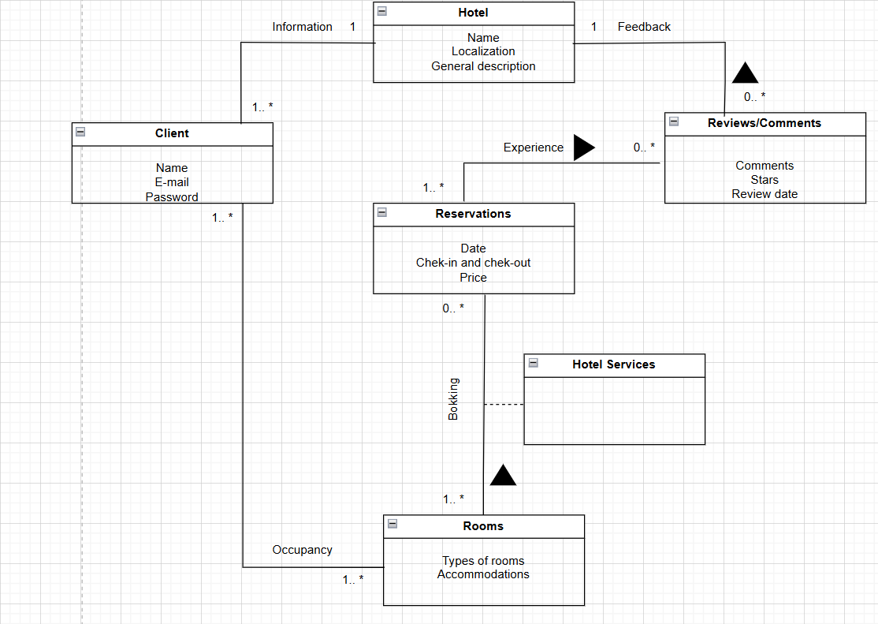

2.1 Glossary
- Client – A person who uses the system to search for hotels, make reservations, and leave comments/reviews. Each client has an associated name, email, and password.
- Hotel – An establishment that offers accommodations and services to clients. It includes data such as name, location, and a general description. Hotels can receive reviews from clients.
- Rooms – Accommodation units within the hotel. They include information such as room type and amenities.
- Reservations – A record of a client’s stay in a hotel room. It contains details such as reservation date, check-in and check-out dates, and the price.
- Hotel Services – Services provided by hotels, such as breakfast, Wi-Fi, spa, among others. These are associated with the reservations made by clients.
- Reviews/Comments – Opinions and ratings left by clients after their stay. They include comments, star ratings, and the date of the review.
3

